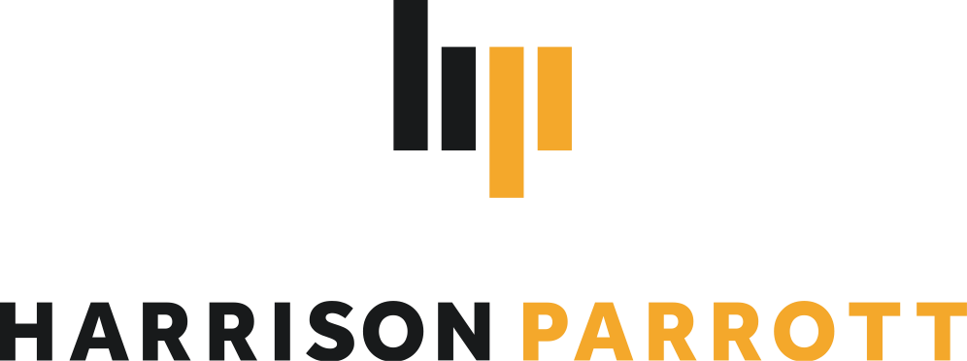

Goldmund Quartet

# String Quartet

Praised for their “exquisite playing” and “multi-layered homogeneity” by Süddeutsche Zeitung, the Goldmund Quartet inspires audiences worldwide with its inwardness, unbelievably fine intonation, and phrases worked out down to the smallest detail. These qualities have led to some of the finest interpretations of both classical and contemporary chamber music repertoire.

The Quartet’s 2025/26 season’s highlights include a substantial U.S. tour with performances in Boston, Houston and Miami, as well as masterclasses in collaboration with the Tokyo University of the Arts. The Quartet returns to celebrated festivals including Schubertiade Hohenems, Schleswig-Holstein Musik Festival and Rheingau Musik Festival, where they will perform alongside Martynas Levickis. Further engagements feature appearances at Alte Oper Frankfurt with Raphaela Gromes, Liederhalle Stuttgart, and concerts in Leiden and Warsaw. They will also join forces with Sabine Meyer for performances in Grünwald and Bamberg, and collaborate with Fazil Say at Musikfestspiele Potsdam Sanssouci. In June 2026, the Quartet curates the second edition of their own chamber music festival at Kloster Irsee, continuing their commitment to artistic collaboration and musical exploration.

Collaborations with composers such as Kaan Bulak, Jörg Widmann and others prove their dedication to commissioning and performing contemporary music. These efforts alongside educational projects are supported by the Friends of Goldmund Quartett e.V.

The Goldmund Quartet has performed alongside artists such as Jörg Widmann, Ksenija Sidorova, Sabine Meyer, Pablo Ferrández, Nino Gvetadze, Noa Wildschut, Martynas Levickis, Maximilian Hornung, Elisabeth Brauß, Christian Gerhaher and Fazil Say.

Their most recently released album, *Dahoam*, is a musical exploration of their Bavarian background, achieved through an innovative mixture of folk and classical music. Known for tremendous musical versatility, the Quartet’s albums have similarly featured both traditional classical and contemporary works from Schubert and Mendelssohn to Wolfgang Rihm and Dobrinka Tabakova. The Quartet's 2023 *Prisma* album featured contemporary works by Arvo Pärt, Philip Glass and Uno Helmersson, alongside two newly commissioned pieces by Pascal Schumacher and Sophia Jani.

In 2016, the Quartet won the Bayrischer Kunstförderpreis and the ARD Competition’s Karl Klinger Prize. Winners of the 2018 International Wigmore Hall String Competition and the 2018 Melbourne International Chamber Music Competition, the Goldmund Quartet were named as Rising Stars by the European Concert Hall Organisation for 2019/20.

Since 2019, they have been performing on Antonio Stradivari's Paganini Quartet, provided by the Nippon Music Foundation. The Quartet was also awarded the Jürgen Ponto Foundation Music Prize in March 2020.

In addition to studies at the Hochschule für Musik und Theater in Munich and with members of the Alban Berg Quartet, including Günter Pichler at the Escuela Superior de Música Reina Sofia and the Artemis Quartet in Berlin, master classes and studies with members of the Hagen, Borodin, Belcea, Ysaye and Cherubini Quartets, Ferenc Rados, Eberhard Feltz and Alfred Brendel gave the Quartet important musical impulses.