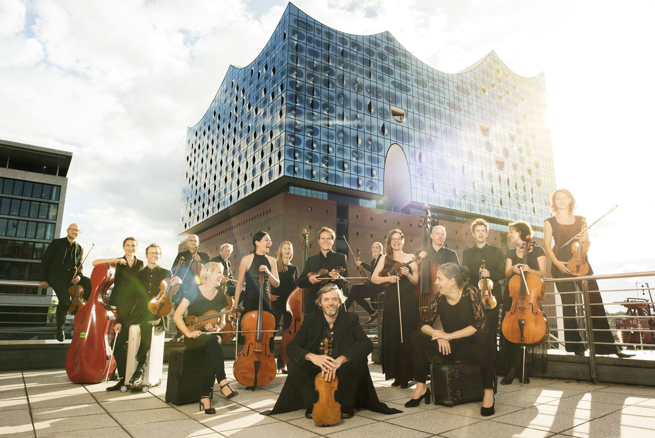

© Tobias Schult

With its unique enthusiasm and artistic quality, Ensemble Resonanz ranks among the world’s leading chamber orchestras. Their concepts connect classical and contemporary music, and their vivid interpretations create a field of resonance between the music, the audience and the stories that develop around the programmes.

The string ensemble consists of twenty-one members, organised democratically. The musicians work without a permanent conductor, inviting artistic partners on a regular basis instead. Violinist and conductor Riccardo Minasi has been the ensemble’s »principal guest conductor & partner in crime«. Previous close artistic partnerships of the ensemble include the violist Tabea Zimmermann, the violinist Isabelle Faust, the cellist Jean-Guihen Queyras, the conductor Emilio Pomàrico, and the scenographer Annette Kurz as the first visual artist who has accompanied the ensemble as artist in residence. Another driving force of the ensemble’s artistic work is the collaboration with composers and the constant development of new repertoire.

In Hamburg, the ensemble performs in two unique and very different locations: The Elbphilharmonie and the resonanzraum St. Pauli. The ensemble’s residency at the Elbphilharmonie includes the concert series »resonanzen« which has been running with great success for more than 20 seasons. With its children’s concerts and various projects at festivals, the ensemble has a formative influence on the Elbphilharmonie’s programming, always emphasizing the vivid presentation of classical and contemporary music.

The resonanzraum – Europe’s first urban chamber music club – is the home of Ensemble Resonanz, located within a converted bunker in the heart of St. Pauli. Here, the musicians present their monthly concert series »urban string«, developed by the musicians themselves and presented in co-operation with international DJs and artists from the electronic music scene. The resonanzraum is also where the ensemble’s »anchor events« take place: Open rehearsals (»werkstatt«), introductions (»hörstunde«) and philosophical discussions (»bunkersalon«) open up spaces for new experience associated with the concert programmes. The resonanzraum has received multiple prizes, including Hamburg’s Music Club of the Year award in 2017 and the Applaus Award in 2023 for its innovative programming, and the international AIT-Architectural-Award as well as the BDA audience award for its unique architecture. The concert series »urban string« won the Innovation Award at the Classical Next Conference in 2016.

Based in Hamburg, the musicians perform at various festivals and in major concert halls around the world, captivating audiences from Vienna to Tokyo.