christoph **koncz**

Music Director . *Orchestre National de Mulhouse*

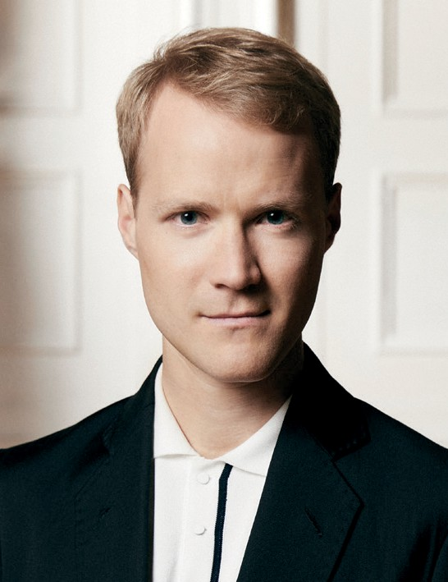Chief Conductor . *Deutsche Kammerakademie Neuss am Rhein* Principal Guest Conductor . *Les Musiciens du Louvre* <https://www.harrisonparrott.com/artists/christoph-koncz>

The young Austrian conductor Christoph Koncz has already established himself as one of the outstanding musicians of his generation, performing worldwide with orchestras such as the London Symphony Orchestra, Orchestre de Paris, Sächsische Staatskapelle Dresden, Orchester der Wiener Staatsoper, Israel Philharmonic Orchestra, Mahler Chamber Orchestra, Orchestre de la Suisse Romande, hr‑Sinfonieorchester Frankfurt, Orchestre Métropolitain de Montréal and Hong Kong Philharmonic as well as at opera houses such as the Opernhaus Zürich, National Theatre Prague, Teatro Real Madrid and Wiener Staatsoper.

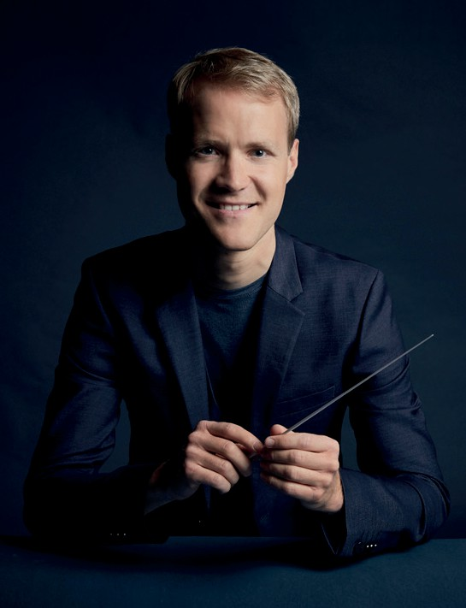During the upcoming season, Christoph Koncz will among others return to the Philharmonia Orchestra London, Swedish Radio Symphony Orchestra and Deutsches Symphonie‑Orchester Berlin. He will also appear for the first time with the Cleveland Orchestra at their famed Severance Music Center. He will conduct a new production of *Hänsel und Gretel* at the Opéra national du Rhin Strasbourg and a performance series of *Don Giovanni* at the Wiener Staatsoper.

Christoph Koncz has been Music Director of the Orchestre National de Mulhouse since 2023 and Chief Conductor of the Deutsche Kammerakademie Neuss am Rhein since 2019. He has also been appointed Principal Guest Conductor of the renowned French period instrument ensemble *Les Musiciens du Louvre* and enjoys a close partnership with the Verbier Festival Chamber Orchestra. His conducting debut at the 2013 Salzburg Mozartwoche was followed by concerts at such prestigious venues as the Berlin, Cologne, Hamburg and Munich Philharmonie, Vienna Musikverein and Konzerthaus, KKL Lucerne and Concertgebouw Amsterdam as well as at the Salzburg Festival.

Born 1987 in Konstanz into an Austrian‑Hungarian family of musicians, Christoph Koncz received his first violin lessons at the age of four. Only two years later he entered the Vienna University of Music, where he also enrolled in the conducting class of Mark Stringer in 2005. Master classes with Daniel Barenboim, Daniel Harding and David Zinman further enriched his musical education. At the age of just nine, he received worldwide acclaim for starring as child prodigy Kaspar Weiss in the Canadian feature film *The Red Violin*, which won an Academy Award for Best Original Score. In 2008, at the age of twenty, Christoph Koncz was appointed principal second violin of the Vienna Philharmonic, a position he has held until 2023.



[christoph](https://youtube.com/playlist?list=PLOiT09erybnNkMWsyKJsRmvQGDyNrE8_f)

[**konc z**](https://youtube.com/playlist?list=PLOiT09erybnNkMWsyKJsRmvQGDyNrE8_f)

[**Smetana Liszt Brahms Beethoven Schumann Schubert Strauß**](https://youtube.com/playlist?list=PLOiT09erybnNkMWsyKJsRmvQGDyNrE8_f)

Christoph Koncz is particularly noted for his interpretation of the works by Wolfgang Amadeus Mozart. His recording of the Complete Violin Concertos as soloist and conductor with *Les Musiciens du Louvre* was released by Sony Classical in 2020 under the title *Mozart's Violin* and caused an international sensation for being the first recording of these famous works on the composer's original Baroque violin.

— Concert season 2025/26