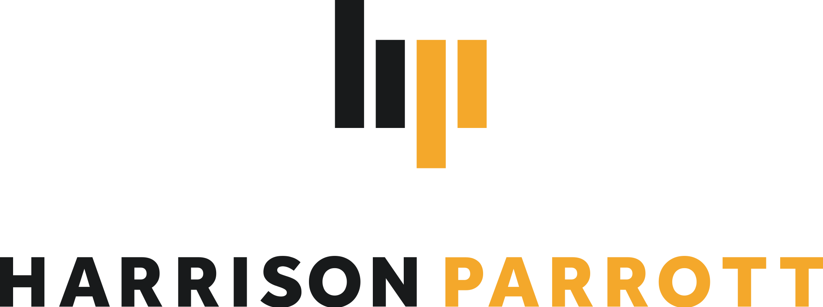

Tabita Berglund
Conductor

Hailed as “one of Europe’s greatest promises” (Helsingin Sanomat), Tabita Berglund is one of today’s most exciting, talented young conductors who is fast gaining a reputation for her alert, charismatic and inspiring style which elicits “exceptional music-making” (The Arts Desk). Berglund is currently Principal Guest Conductor of the Kristiansand Symphony Orchestra, appointed to this post following her debut engagement with the orchestra in 2020.
Highlights of 2022/23 include Berglund’s London debut with the Philharmonia (Royal Festival Hall), US debut/subscription concerts with the Detroit Symphony Orchestra and German debut/season-opening concerts with the Sinfonieorchester Wuppertal. Berglund also makes her debut with the BBC Scottish Symphony Orchestra, Orchestre National du Capitole de Toulouse, Malmö Symphony Orchestra and Orquesta Sinfonica de RTVE in Madrid, while return visits include the Royal Stockholm Philharmonic, Finnish Radio Symphony and Bergen Philharmonic orchestras as well as her fourth guest appearance each with the Hallé and Royal Scottish National Orchestra.
2022/23 also marks the second season of Berglund’s tenure with the Kristiansand Symphony Orchestra – KSO repertoire and soloist highlights include Mahler’s Symphony No.1, Tchaikovsky’s Symphony No.6 and cellist Tanja Tetzlaff, while across the season Berglund also joins forces with Truls Mørk, Edgar Moreau, Stephen Hough and Randall Goosby, among others, with repertoire by Beethoven and Schubert through to composers such as Lutoslawski, Nordheim, Thorvaldsdottir and Tabakova. Looking further ahead, future opera activity includes a revival production of Mozart’s Le nozze di Figaro, while recent engagements include Berglund’s Austrian and French debuts with the Tonkünstler-Orchester Niederösterreich and Orchestre National de Lille respectively, as well as appearances with the Oslo Philharmonic Orchestra, Orquesta Sinfónica de Tenerife, Luzerner Sinfonieorchester, Tampere Philharmonic Orchestra, Stavanger Symphony Orchestra, Trondheim Symfoniorkester, Norwegian National Opera Orchestra, Orquesta Ciudad de Granada and Tapiola Sinfonietta, among others.
Berglund graduated in 2019 from the Orchestral Conducting Masters course at the Norwegian Academy of Music, where she studied under Professor Ole Kristian Ruud. She originally trained as a cellist and studied to Master’s degree level under Truls Mørk, performing regularly with the Oslo and Bergen Philharmonic orchestras as well as the Trondheim Soloists before conducting became her main focus in 2015. She was the 2018–20 star of the Talent Norway programme and is a past recipient of the Gstaad Conducting Academy’s Neeme Järvi Prize. Berglund’s debut CD, on which she conducts the Oslo Philharmonic with violinist Sonoko Miriam Welde, was released in 2021 (LAWO) and subsequently nominated for a Norwegian Grammy (Spellemann) in the 2022 Classical Music category.

