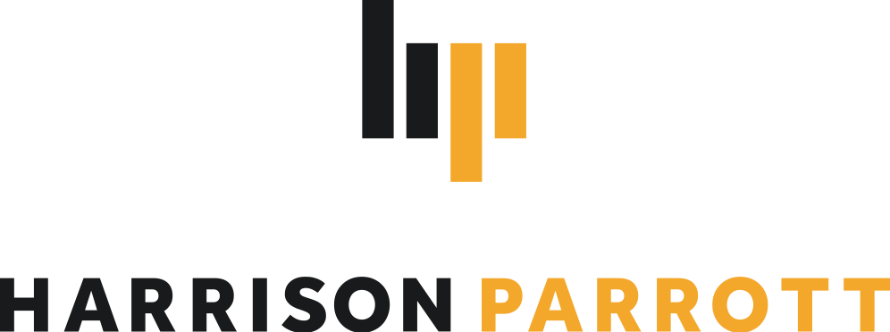

Alex Otterburn
Baritone

A recent graduate of the Royal Academy, Alex has an exciting first season ahead of him as he joins Scottish Opera as a 2017/18 Emerging Artist. His roles include Eddy in Joe Hill-Gibbins’ new production of Greek at the Edinburgh International Festival and in Glasgow, as well as Harlequin in Antony McDonald’s new production of Ariadne auf Naxos, and Marchese D'Obigny in Sir David McVicar’s production of La traviata. After these productions, Alex will reprise the role of Harlequin for Opera Holland Park as well as joining the Grange Festival as Pallante in Agrippina. Further ahead Alex joins ENO as a Harewood Artist, as well as making his company debut with Opera North.

Highlights last season included Alex’s critically acclaimed debuts as Guglielmo in Daisy Evans’ production of Così fan tutte for Bury Court Opera and John Styx in the Royal Academy’s production of Orphée aux enfers. Other roles at the Academy have included, Kalenik (Rimsky-Korsakov’s May Night), Mercurio (L’incoronazione di Poppea) and Marco (Gianni Schicchi). Elsewhere, Alex made his European concert debut as Curio (Giulio Cesare) at the Concertgebouw with the Symphonie Atlantique alongside Lawrence Zazzo, Anna Christy and Patricia Bardon, in addition to making his debut as Schaunard (La bohème) with the Lyric Opera and RTÉ Concert Orchestra conducted by David Heusel. Recent seasons have also featured the title role in Eugene Onegin at the Dartington International Festival under Sian Edwards, and Malatesta (Don Pasquale) on tour across the UK with Opera Holloway.

Building a diverse concert repertoire, Alex has sung Beethoven’s Symphony No.9, Haydn’s The Seasons, Bach’s Christmas Oratorio, Brahms’ Ein Deutsches Requiem and Vaughan Williams’ A Sea Symphony. Most recently Alex impressed with a selection of Mozart arias with L'Orchestre de Chambre de Genève under Arie van Beek as part of his commitments at the prestigious Georg Solti Accademia.

Alex gained a first class degree in Economics from the University of Manchester before embarking on his studies at the DIT Conservatory in Dublin. A 2014 winner of the International Opera Awards bursary, Alex is supported by the Sickle Foundation, the Josephine Baker and Lucille Graham trusts. He is also the proud recipient of an Independent Opera Fellowship award.

2017/18 season only. Please contact HarrisonParrott if you wish to edit this biography.

