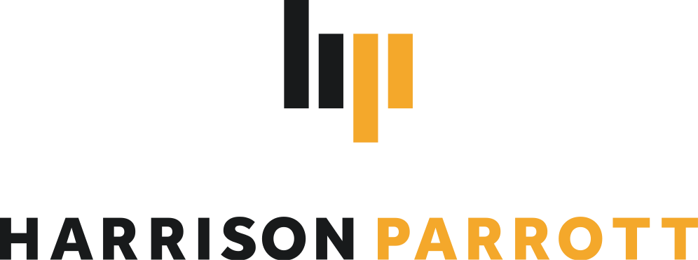
Goldmund Quartet

String Quartet

The Goldmund Quartet is known to feature “exquisite playing” and such “multi-layered homogeneity” (Süddeutsche Zeitung) in its interpretations of the great classical and modern works of the quartet literature. Its inwardness, the unbelievably fine intonation and the phrases worked out down to the smallest detail inspire audiences worldwide.

The Quartet is now counted amongst the leading string quartets of the younger generation worldwide which is reflected in their 2023/24 season calendar. Highlights include the Quartet’s debut at prestigious festivals such as Festival Dolomites, Settimane Musicali di Ascona and Viotti Festival in Vercelli, Italy. The ensemble will return to important halls such as Concertgebouw Amsterdam in a recital with pianist Fazil Say, to Tokyo Opera City as part of a tour of Japan as well as to the United States for a substantial tour to take in Boston and many others. Further return visits lead the Quartet to the renowned Hörtnagel series in Munich, Haus der Musik Innsbruck and Schwetzingen Festival.

The winners of the renowned 2018 International Wigmore Hall String Competition and the
2018 Melbourne International Chamber Music Competition have been selected by the European Concert Hall Organisation as Rising Stars of the 2019/20 season. Since 2019, they have been performing Antonio Stradivari's Paganini Quartet, provided by the Nippon Music Foundation. In addition, the Quartet was awarded the Jürgen Ponto Foundation Music Prize in March 2020 and the Freiherr von Waltershausen Prize in December 2020. In 2016, the Quartet was already a winner of the Bavarian Arts Promotion Prize and the Karl Klinger Prize of the ARD Competition.

Following their 2020 release on Berlin Classics of Travel Diaries, the Quartet's third album with works by Wolfgang Rihm, Ana Sokolovic, Fazil Say and Dobrinka Tabakova, 2023 marks the release of two new important recordings. Enigma, published on Berlin Classic’s Neue Meister series as a limited vinyl release features contemporary works by Arvo Pärt, Philip Glass and Uno Helmersson alongside two newly commissioned pieces by Pascal Schumacher and Sophia Jani. The Death and the Maiden is a recording of works by Schubert, in the Quartet’s own words: “The eternal wanderer has fascinated and accompanied us since the beginning of our quartet life, his chamber music was among the first works we performed”.

Chamber music partners include artists such as Jörg Widmann, Ksenija Sidorova, Alexander Krichel, Alexey Stadler and Wies de Boevé, Nino Gvetadze, Noa Wildschut, Elisabeth Brauss, Maximilian Hornung, Frank Dupree, Simon Höfele.

In addition to studies at the Hochschule für Musik und Theater in Munich and with members of the Alban Berg Quartet, including Günter Pichler at the Escuela Superior de Música Reina Sofia and the Artemis Quartet in Berlin, master classes and studies with members of the Hagen, Borodin, Belcea, Ysaye and Cherubini Quartets, Ferenc Rados, Eberhard Feltz and Alfred Brendel gave the quartet important musical impulses.

2023/24 season only. Please contact HarrisonParrott if you wish to edit this biography.

